Installing cluster on bare metal

These two basic types of OpenShift Container Platform clusters are frequently called:

* Installer-provisioned infrastructure clusters.
* User-provisioned infrastructure clusters.

Both cluster types have the following characteristics:

* Highly available infrastructure with no single points of failure is available by default.
* Administrators maintain control over what updates are applied and when.

### installation program

You can use the installation program to deploy both types of clusters. The installation program generates main assets such as Ignition config files for the bootstrap, master, and worker machines. You can start an OpenShift Container Platform cluster with these three configurations and correctly configured infrastructure

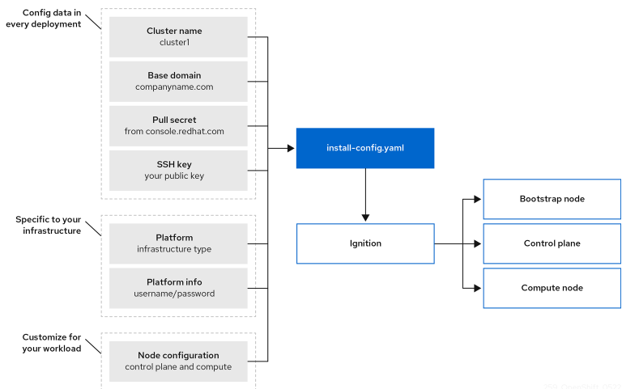

### Installation process

When you install an OpenShift Container Platform cluster, you download the installation program from the appropriate [Infrastructure Provider](https://console.redhat.com/openshift/install) page on the OpenShift Cluster Manager site. This site manages:

* REST API for accounts
* Registry tokens, which are the pull secrets that you use to obtain the required components
* Cluster registration, which associates the cluster identity to your Red Hat account to facilitate the gathering of usage metrics

In OpenShift Container Platform 4.11, the installation program is a Go binary file that performs a series of file transformations on a set of assets. The way you interact with the installation program differs depending on your installation type.

* For clusters with installer-provisioned infrastructure, you delegate the infrastructure bootstrapping and provisioning to the installation program instead of doing it yourself. The installation program creates all of the networking, machines, and operating systems that are required to support the cluster.
* If you provision and manage the infrastructure for your cluster, you must provide all of the cluster infrastructure and resources, including the bootstrap machine, networking, load balancing, storage, and individual cluster machines.

You use three sets of files during installation: an installation configuration file that is named install-config.yaml, **Kubernetes manifests**, and **Ignition config** files for your machine types.

#### The installation process with installer-provisioned infrastructure

The default installation type uses installer-provisioned infrastructure. By default, the installation program acts as an installation wizard, prompting you for values that it cannot determine on its own and providing reasonable default values for the remaining parameters. You can also customize the installation process to support advanced infrastructure scenarios. The installation program provisions the underlying infrastructure for the cluster.

You can install either a standard cluster or a customized cluster. With a standard cluster, you provide minimum details that are required to install the cluster. With a customized cluster, you can specify more details about the platform, such as the number of machines that the control plane uses, the type of virtual machine that the cluster deploys, or the CIDR range for the Kubernetes service network.

If possible, use this feature to avoid having to provision and maintain the cluster infrastructure. In all other environments, you use the installation program to generate the assets that you require to provision your cluster infrastructure.

With installer-provisioned infrastructure clusters, OpenShift Container Platform manages all aspects of the cluster, including the operating system itself. Each machine boots with a configuration that references resources hosted in the cluster that it joins. This configuration allows the cluster to manage itself as updates are applied.

#### The installation process with user-provisioned infrastructure

You can also install OpenShift Container Platform on infrastructure that you provide. You use the installation program to generate the assets that you require to provision the cluster infrastructure, create the cluster infrastructure, and then deploy the cluster to the infrastructure that you provided.

If you do not use infrastructure that the installation program provisioned, you must manage and maintain the cluster resources yourself, including:

* The underlying infrastructure for the control plane and compute machines that make up the cluster
* Load balancers
* Cluster networking, including the DNS records and required subnets
* Storage for the cluster infrastructure and applications

If your cluster uses user-provisioned infrastructure, you have the option of adding RHEL compute machines to your cluster.

Bootstrapping a cluster involves the following steps:

1. The bootstrap machine boots and starts hosting the remote resources required for the control plane machines to boot. (Requires manual intervention if you provision the infrastructure)
2. The bootstrap machine starts a single-node etcd cluster and a temporary Kubernetes control plane.
3. The control plane machines fetch the remote resources from the bootstrap machine and finish booting. (Requires manual intervention if you provision the infrastructure)
4. The temporary control plane schedules the production control plane to the production control plane machines.
5. The Cluster Version Operator (CVO) comes online and installs the etcd Operator. The etcd Operator scales up etcd on all control plane nodes.
6. The temporary control plane shuts down and passes control to the production control plane.
7. The bootstrap machine injects OpenShift Container Platform components into the production control plane.
8. The installation program shuts down the bootstrap machine. (Requires manual intervention if you provision the infrastructure)
9. The control plane sets up the compute nodes.
10. The control plane installs additional services in the form of a set of Operators.

The result of this bootstrapping process is a running OpenShift Container Platform cluster. The cluster then downloads and configures remaining components needed for the day-to-day operation, including the creation of compute machines in supported environments.

### Required machines for cluster installation